2_ Implementation of BGP using AS_path attribute.

Aim: Implementation of BGP using AS_path attribute.
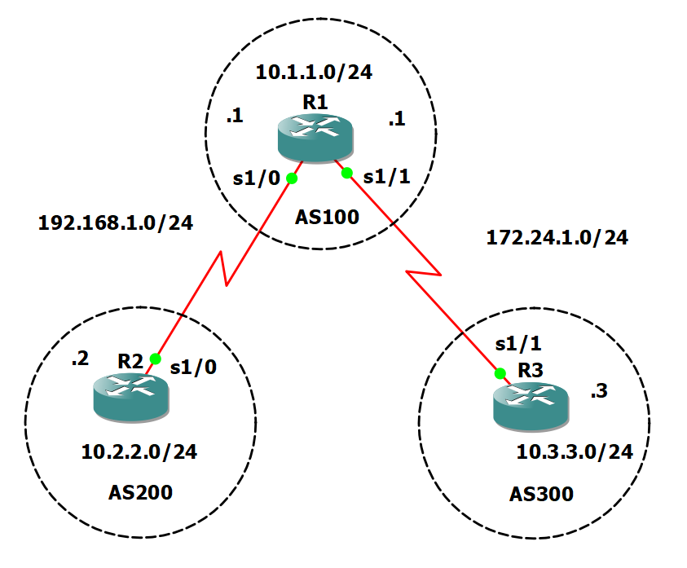
Take 3 routers -> Configure -> slots -> NM-4T
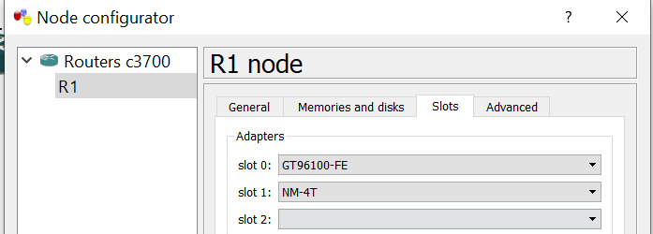

On Router console type following commands one by one.
R1 Console

conf t
int s1/0
ip add 192.168.1.1 255.255.255.0
no sh
int s1/1
ip add 172.24.1.1 255.255.255.0
no sh
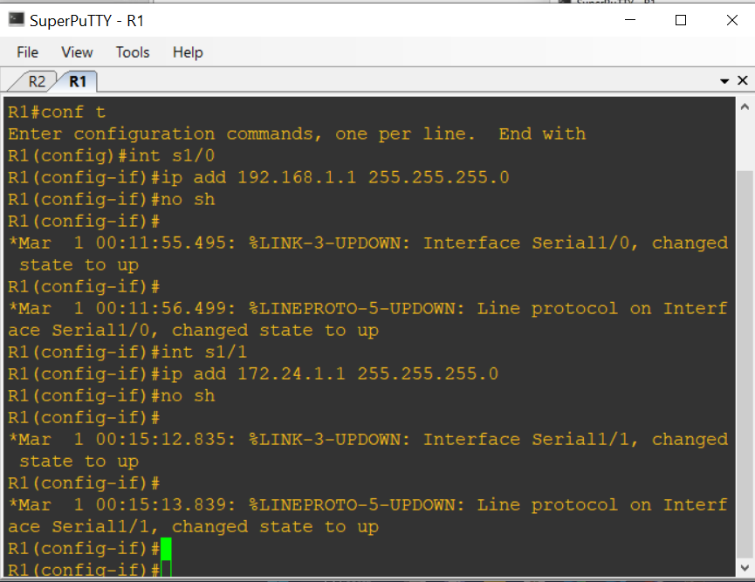

R2 Console
conf t
int s1/0
ip add 192.168.1.2 255.255.255.0
no sh
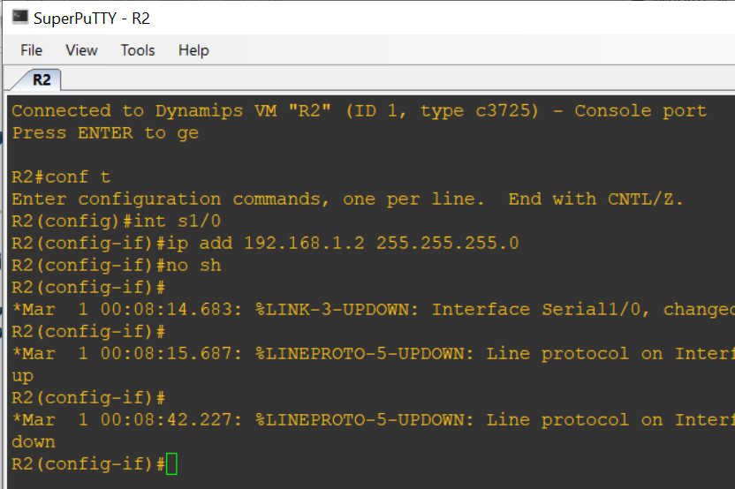
R3 Console
conf t
int s1/1
ip add 172.24.1.3 255.255.255.0
no sh
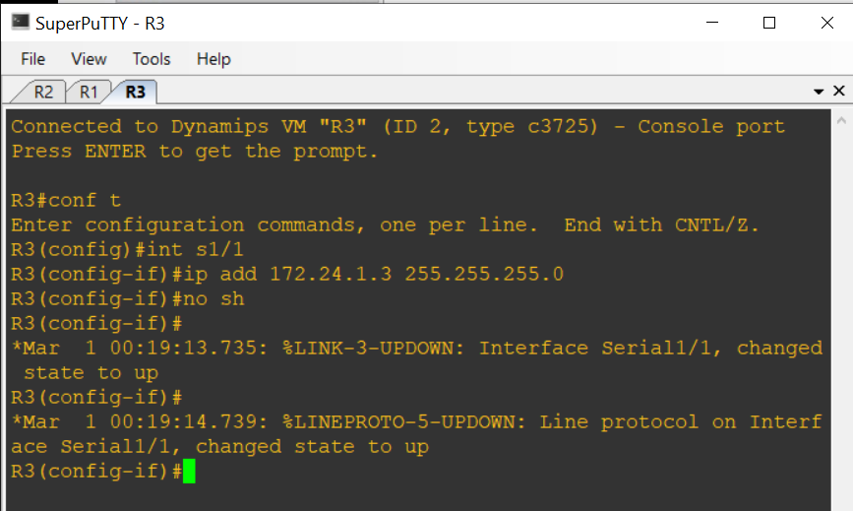

To add loopback address ,On Router console type following commands one by one.
R1 Console
int lo0
ip add 10.1.1.1 255.255.255.0
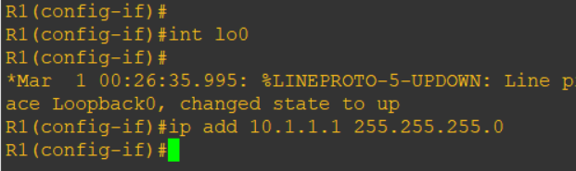

R2 Console
int lo0
ip add 10.2.2.2 255.255.255.0

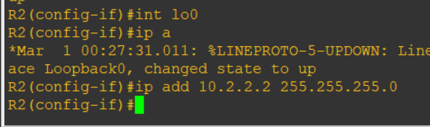

R3 Console
int lo0
ip add 10.3.3.3 255.255.255.0

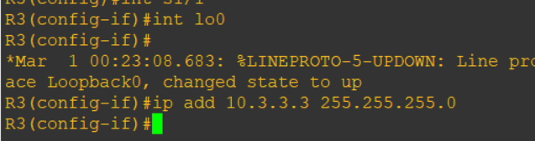

To add bgp protocol, On Router console type following commands one by one.
R1 Console
router bgp 100
neighbor 192.168.1.2 remote-as 200
neighbor 172.24.1.3 remote-as 300
network 10.1.1.0 mask 255.255.255.0

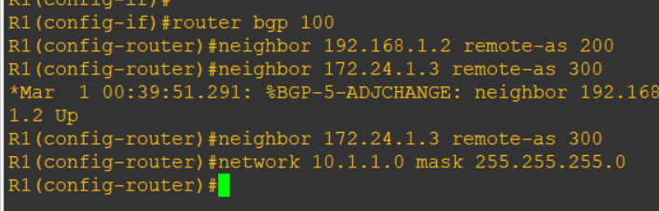

R2 Console
router bgp 200
neighbor 192.168.1.1 remote-as 100
network 10.2.2.0 mask 255.255.255.0

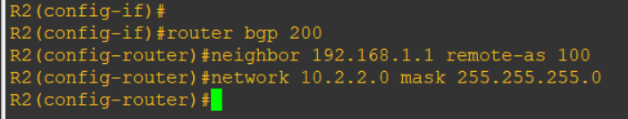

R3 Console
router bgp 300
neighbor 172.24.1.1 remote-as 100
network 10.3.3.0 mask 255.255.255.0

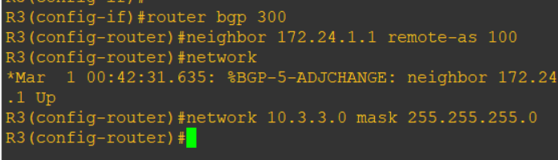

To show ip route type following command in each router console
do sh ip route
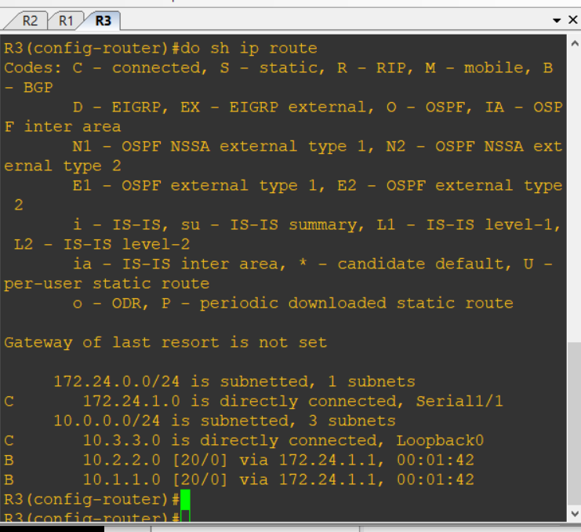

To verify output type following commands: (OUTPUT)

do ping 10.3.3.3 source lo0

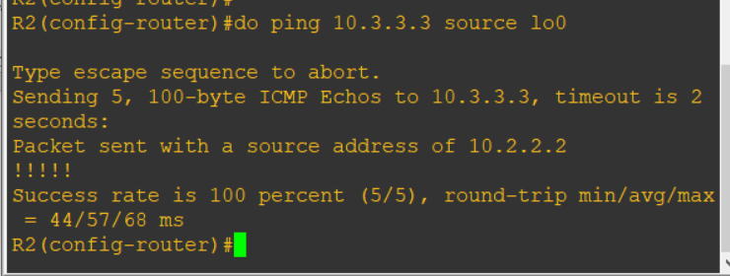

do ping 10.2.2.2 source lo0

